

The American States Assembly
How to Build an Assembly



Introduction
Congratulations on your decision to step up and help build your local or state assembly! This is a huge task, and it takes many hands coming together to do it right. It also takes a foundational understanding of many things – like our history (the REAL story
– not what you were fed in school!), how we were called into session, what the final goal is and what the steps are to get there. Some of these things we know. Some of them we are creating based on information we have.

The foundational principles in this manual are based on the extensive research and writings of Anna Von Reitz and her team of researchers, as well as countless hours of webinar conversations. Wherever there is a reference to an article number, it refers to a particular article written by Anna. All of her articles can be found on www.AnnaVonReitz.com.

Anna Von Reitz
Researcher, Historian, Justice and
Fiduciary of The United States of America

This manual is not meant to replace the vast resources available on the tasa.AmericanStateNationals.org website, but is an adjunct designed to be a guide to the reconstruction itself. This website will frequently point back to other resources for deeper dives into relevant supportive information.

So let’s get started!


Deep Dives
www.AnnaVonReitz.com https://tasa.AmericanStateNationals.org

Section 1: First, a Little History…


Once upon a time there was a brand new baby country that had just won its independence from its motherland, (Great?) Britain. Well… sort of. As it often goes in war, there are negotiations. As this collection of battle weary colonies stood together on the land as a Union of states (The United States) in their new found freedom, they realized that needed some things that

The three subcontractors of
The United States of America
(unincorporated)

1
United States National Government “States of America”
governed by
The Constitution for the united States of America International Land Jurisdiction
1787-1860
Responsible for running general business in the realm of International Commerce

2
Territorial United States Government “the” United States of America governed by
The Constitution of the United States of America International Sea Jurisdiction
1789-present
Military and Territorial Property Management run by the British Territorial United States

3
Municipal United States Government “the” United States
governed by
The Constitution of the United States Global Air Jurisdiction
1790-present
Municipal Business in the care of the Pope and the Holy Roman Empire
they weren’t able to provide on their own. So, they contracted with the Holy See and the British Crown to provide them with certain limited governmental services that fell into the jurisdictions of the air and the sea. They also formed their own American, land- jurisdiction contractor to join the team. Each of these three contractors (translation: corporations) had its
own contract, known as a “Constitution” (yes, there are actually three constitutions!) and worked together to provide governmental services - 19 enumerated powers, to be exact - that were needed to run the country.

The beginning of the fraud… well, some of it anyway!
Skip ahead about a hundred years and things got a little interesting. You see, the motherland wasn’t all that thrilled to have lost this beautiful, abundant, and profitable land a hundred years prior. And now they were angry because the price of cotton produced in America, which they were now dependent upon, was just way too high. So with the help of France, they plotted to take over. But how? The easiest way to take over any group of people is to divide them first. They observed that the issue of slavery and the differences between the “wigs” of the north and the plantation owners of the south were creating tensions. So they decided to use the issue of slavery to divide the people politically, stage a mercenary conflict over it to weaken us, then come in and take over militarily. But first, they made sure they had a British subject in charge whom they could control. Enter stage left, Abraham Lincoln! Yep, good ol’ “honest Abe” was a BAR attorney, holding allegiance to the British Crown. This meant he did not have the status, standing or Provenance to operate as

In web version of this document, include a clip from Bobby Graves video talking about some of the American
History…

In Print version, list links?


the President of The United States of America, unincorporated (land jurisdiction). So as “president”, he actually was operating as CEO for the British territorial corporation known as “the” United States of America. Pretty sneaky, eh?

This statue of Abraham Lincoln is WHERE??
How about… Westminster, London! Hmm, makes you wonder where his true allegiance was?
Hint: British Accreditation Registry (BAR).

The British used good ol’ honest Abe to strike the match and begin this mercenary conflict, which we know as the Civil War. But there was nothing civil about it. Some of the Americans, seeing what was actually going on,
didn’t want to play this game. So on March 27, 1861 to be exact, seven southern nation States of America walked out of the Second Session of the Thirty-sixth Congress, leaving it “sine die” or without a day to reconvene.

Less than three weeks later, on April 15, 1861, “President”
Lincoln reconvened Congress under the Executive branch
by proclamation (General Order 100): “I do hereby, in virtue of the power in me vested by the
Constitution, convene both houses of Congress.” (Hm… which constitution was he referring to you may wonder?) This executive order became the Lieber Code. Click here to check it out: [https://avalon.law.yale.edu/19th_century/lieber.asp ]

But, the 7 southern states that bailed during the war did not return, so 1/3 of our government was missing – and has been missing all this time! In the mean-time, the remaining 2/3 took advantage of this fact to take over, run amock and become the bloated, overreaching, multi-tentacled monster that has fraudulently usurped powers that were never theirs to begin with.


Want more history?
Read more about some of the many great frauds:

Chart: The Great Fraud of 1930-33
Article 644: The Great Fraud of Today - Part One: The Corruption of the Judicial Branch Article 645: The Great Fraud of Today - Part Two: Corporations Are Not Governments Article 646: The Great Fraud of Today, Part Three: Redemption

The Simple Facts – in sum
- Our actual government – which we are owed – is not fully operational.
- It is not functioning as it should be because it was never fully restored after the “Civil War”
- We have not restored it because we were not informed that it needed to be restored – certain parties profited themselves by keeping that obscured



Let There Be Peace!
Did you know that peace was never declared after the Civil War? No wonder the war time flag is still being flown and executive orders are still being created. Well, we have some great news! On August 1, 2021, our Head of State, James Clinton Belcher, officially ended the Civil War by declaring peace with the International Peace Proclamation. Finally!

Click here to check it out. Print it. Frame it. Forward it to your friends.
Mail it to every defacto “official” you know!

Also link to article “Why this Peace Proclamation Works”



The Civil Peacetime Flag
The American people are not at war.

Our States and our Federation of States were never involved in the mercenary conflict known as the Civil War. It was fought completely by the Territorial and Municipal corporations within the air and water jurisdictions. The Land and Soil Jurisdiction has been at peace continuously and remains so to this day. That’s why we fly the Civil Peacetime Flag instead of our wartime flag, Old Glory.

Read more about our flags here: “Declaration of Flag”
Article 649 “Both Flags Belong to Us”
Article 898 “Fundamentals 3 – Your Flags” Article 923 “Our Flags Our History”
Article 1110 “The Real Story of the Star Spangled Banner” Make all of these links

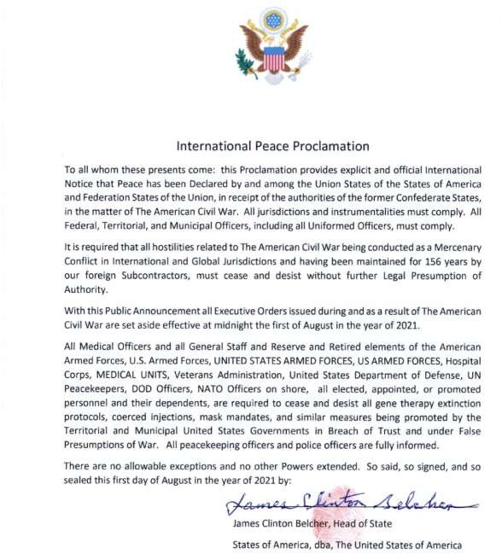

OK, So How Do We Fix This?
How do we get the missing part of our government – the actual American government - “States of
America,” back in the game so they (we!) can take back control of our governing duties, limit the foreign subcontractors to their original 19 enumerated powers and return to the original plan our forefathers created for us?
Easy, we just need to call the states back into session, right? But wait… what are we exactly calling into session?
Check out Section 2 for the answer!



MAXIMS OF LAW

The creation is never greater than the creator
Possession by Pirates does not change ownership
Fraud vitiates everything There is no Statute of Limitations
on Fraud So there.

